24 August 2006 4393 Immediate


Vehicle production – July 2006

Source: | Cars |  | Commercial Vehicles |  | Total vehicles
SMMT Ltd | Jul-06 | YTD 2006 | Jul-06 | YTD 2006 | Jul-06 | YTD 2006
Total | 117,829 | 917,347 | 15,318 | 121,439 | 133,147 | 1,038,786
 | -9.6% | -6.3% | 7.5% | -2.3% | -7.9% | -5.9%
Export | 88,910 | 697,747 | 10,425 | 80,876 | 99,335 | 778,623
 | -5.3% | -1.4% | 22.7% | 8.4% | -4.4% | -0.4%
% of total | 75.5% | 76.1% | 68.1% | 66.6% | 74.6% | 75.0%
Home | 28,919 | 219,600 | 4,893 | 40,563 | 33,812 | 260,163
 | -20.5% | -19.2% | -15.0% | -18.4% | -19.8% | -19.1%
% of total | 24.5% | 23.9% | 31.9% | 33.4% | 25.4% | 25.0%

Car production
'More than three quarters of the UK's July car production was destined for foreign markets', said Christopher Macgowan, SMMT chief executive. 'With European volumes subdued at present, it was of little surprise that the total UK output levels were slightly lower this month. But despite the lower July figures, it is very encouraging to see the likes of Toyota, Honda, Land Rover and Jaguar posting significant growth'
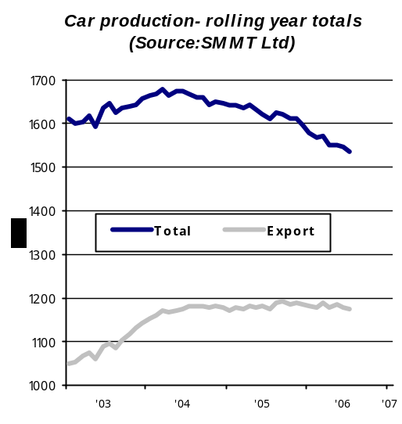

Commercial vehicle production

'A big increase in van production served to boost the commercial vehicle market by 7.5% in July', commented Christopher Macgowan, SMMT chief executive. 'And again exports were a key factor in this rise. Whilst LCVs took the lion's share, at the heavier end, DAF's Leyland truck plant was able to continue to show a modest gain despite the backdrop of purchasing indecision caused by the changes from Euro 3 to Euro 4 standards'
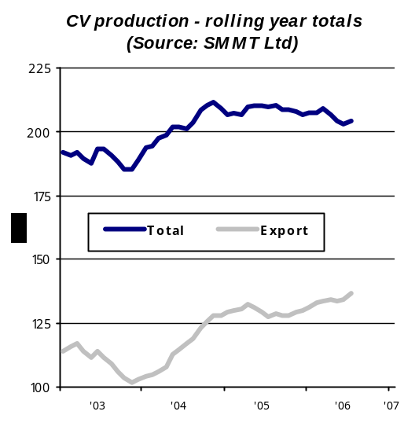

Vehicle production – July 2006

Manufacturing plants profile: Toyota Motor Manufacturing (UK) Ltd.

Vehicle Manufacturing Plant  Burnaston  Derby  Derbyshire  DE1 9TA  Tel: 01332 282121 | Engine Manufacturing Plant  Deeside Industrial Park  Flintshire  North Wales  CH5 2TW  Tel: 01244 282121
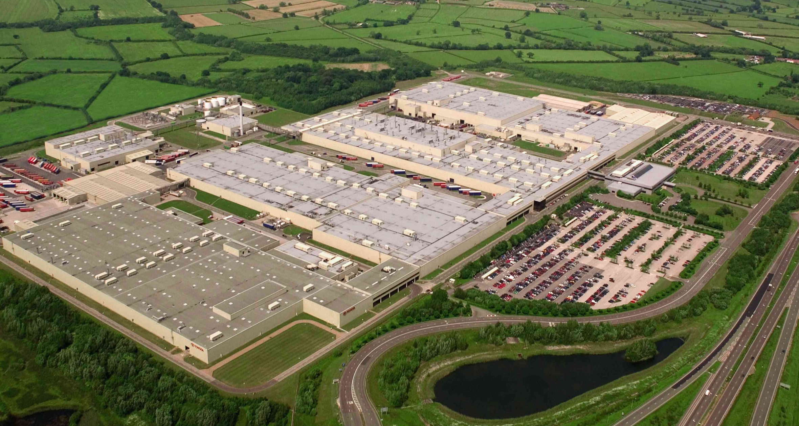 | 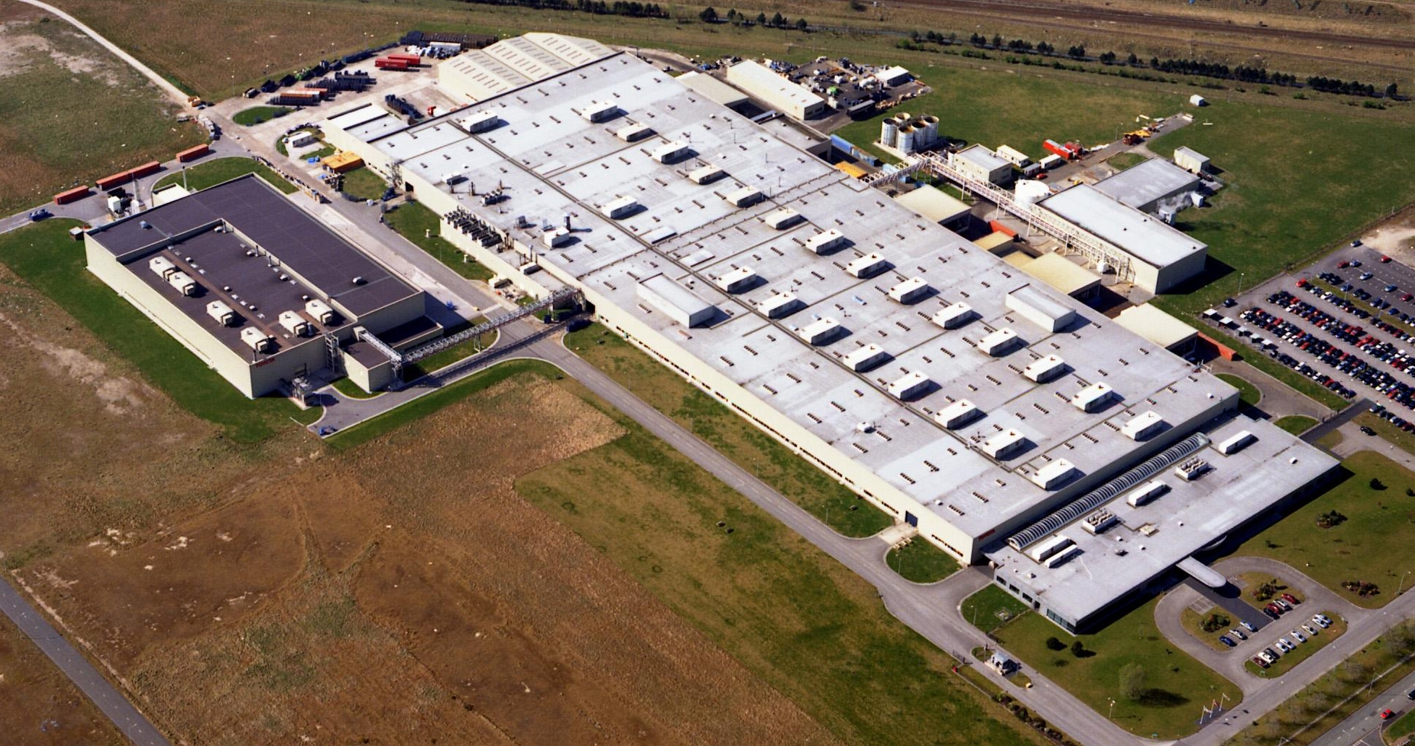
Plant Statistics:  Employees: 4,200  Plant size: 580 acres/2.35 million m²  Investment: £1.15 billion  Start of production: 16 December 1992  Processes: Pressing of panels, welding, painting  plastic moulding and assembly  Models: Avensis 4 /5 door & Estate  Corolla 3/5 door liftback  2005 Production: Total: 264,000 vehicles.  156,000 Avensis  108,000 Corolla | Plant Statistics:  Employees: 681  Plant size: 115 acres/0.48 million m²  Investment: £600 million  Start of production: 8 September 1992  Processes: Aluminium casting, machining,  assembly and testing  Engines: VVT-i 1.6/1.8/2.0L petrol  Plus machined parts for export  2005 Production: 188,000 assembled engines.  Plus 300,000 machined sets for  export to Toyota plants worldwide.
Company milestones  1992 First engine and vehicle (Carina E)  1993 First engine exported to Japan  1998 Introduction of second model (Corolla)  1999 500,000th car exported  2001 1,000,000th engine and vehicle produced  2003 New generation Avensis export to Japan  2005 2,000,000th engine and vehicle produced | Environmental Philosophy:  TMUK’s environmental policy reflects Toyota’s global earth charter. It was Toyota’s first overseas plant and the UK’s first car manufacturer to win ISO 14001 certification. It was also Toyota’s first overseas plant to use water-borne paints. All efforts are underpinned by Toyota's 5Rs philosophy that seeks to eliminate the amount of waste involved in processes. The 5Rs focus on the Refinement, Reduction, Re-use, Recyclability and the Retrieval of energy throughout the company, by building in environmental considerations, minimising waste generation at source, re-using packaging, recycling material in the same or different processes and optimising energy resources. In 2003 TMUK became the first UK car maker to achieve the environmental target of achieving zero waste to landfill from both plants.
Company Awards  1993 Awarded Investors in People (continued reaccredidation 1993-2006)  1994 Awarded ISO9002 Quality Management (cont reaccredidation)  1996 Awarded IS014001 Environmental Management (cont reaccredidation)  1997 Awarded Queen’s Award for Export.  2001 Awarded RoSPA Sir George Earle Trophy  (Industry sector award winners 2001, 2002, 2003 & 2005)  2002 Corolla awarded What Car? ‘Car of the Year’  2004 BITC Big Tick Award for Environmental Impact  2005 Awarded second Queen’s Award for Export  2006 BCE Award for ‘Zero Waste to Landfill’ | Press Contacts:  Toyota Manufacturing UK  Steve Carter - Communications & External Affairs  Direct line: +44 (0) 1332 283607  steve.carter@toyotauk.com

